1st CONCEPT 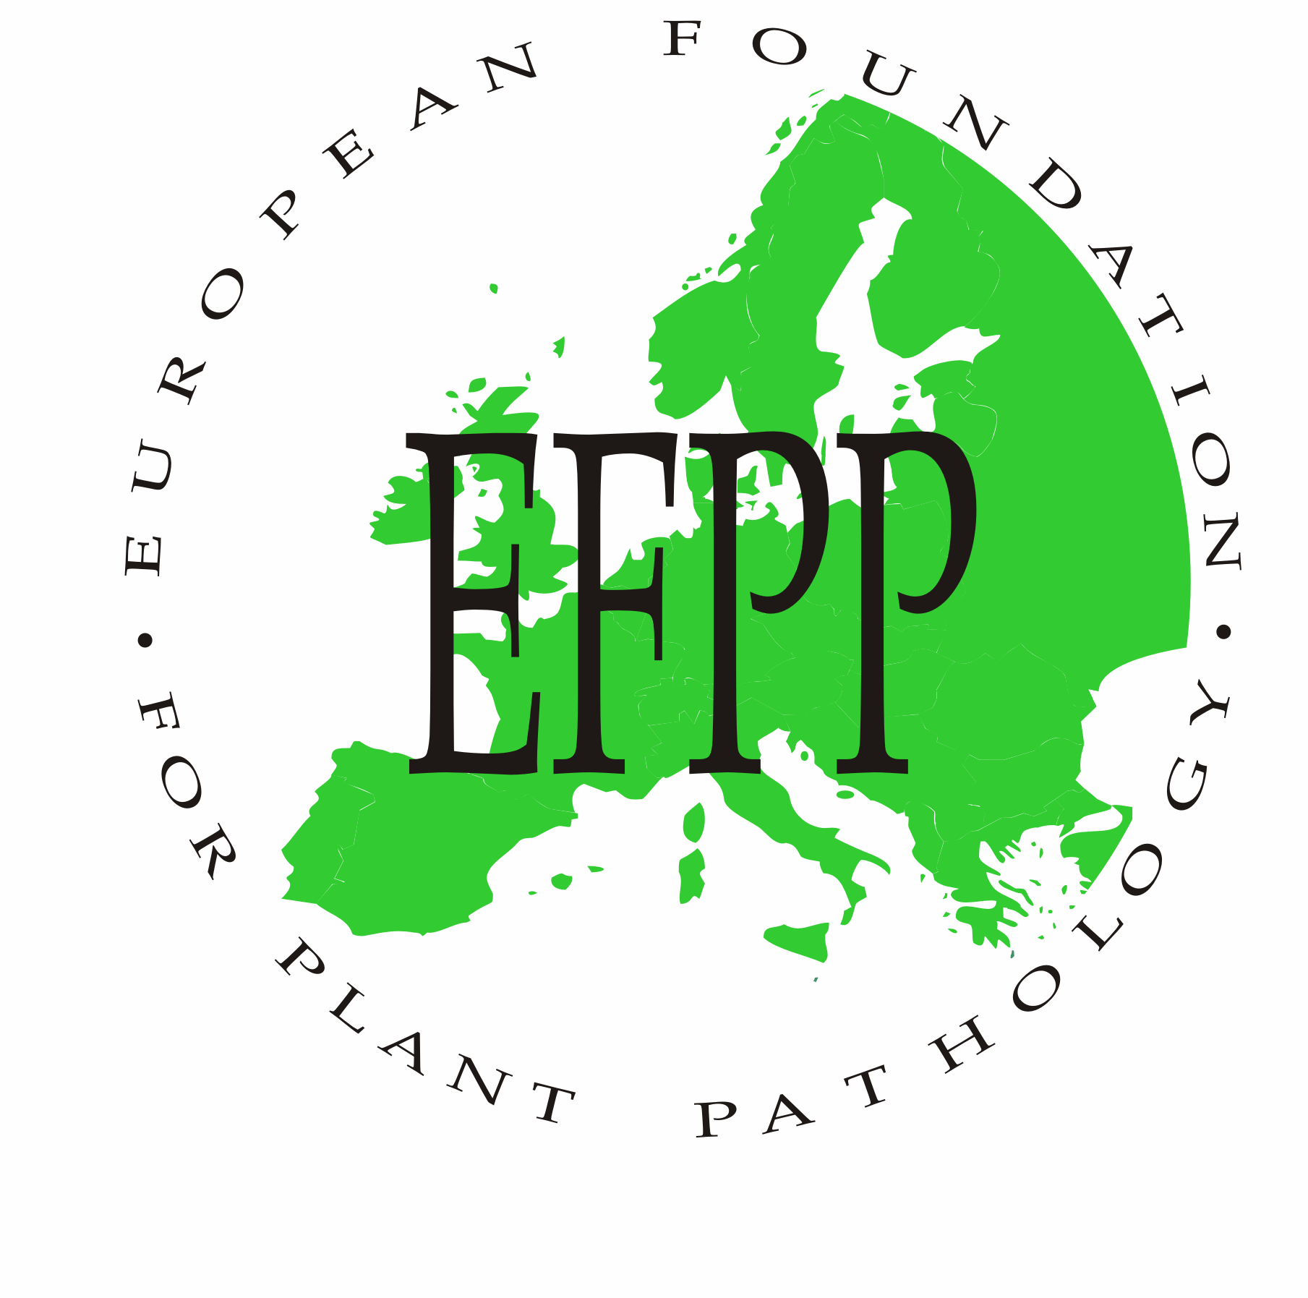

AGENDA FOR THE 11th MEETING OF
THE BOARD OF THE EFPP
WITH DELEGATES OF MEMBER SOCIETIES

Wageningen, Monday, October 1st 2012, 18.00 – 19.30 hours

- Opening address by the President Dr. P. Boonekamp
- Minutes of the 10th Board Meeting in Évora and matters arising
- Report of the General Secretary, Dr. G. Kema
- Report of the Treasurer, Dr. A. Hermansen
- EJPP: Report of the Editor-in-chief, Prof. M. Jeger

- Election and appointment of officers of the EFPP:
- Appointment of the President: Prof. M. Manka
- Appointment of the vice-president: Dr. P. Boonekamp
- Appointment of the treasurer: Dr. A. Hermansen
- Appointment of the general secretary: Dr. G. Kema
- Appointment of the Programme Secretary: To be appointed by the Polish organizing committee.

- Report of the 9th EFPP-Conference 2010 in Évora en and acknowledgement to the resigning officer Prof. M.I. Clara and her team.

- Status Report of the 10th EFPP-Conference 2012 in Wageningen (Dr P. Boonekamp)

- Progress Report of the 11th EFPP-Conference 2014 in Poland (Prof M. Manka). [addition of details after I have a reaction of M. Manka]

- Society bidding for the 12th EFPP conference 2016 (bid opportunity for Member Societies)

- Future of EFPP: [we need to prepare this agenda point, and add some lines or even better a short document to be discussed at the meeting]

- Any other business
- closing

