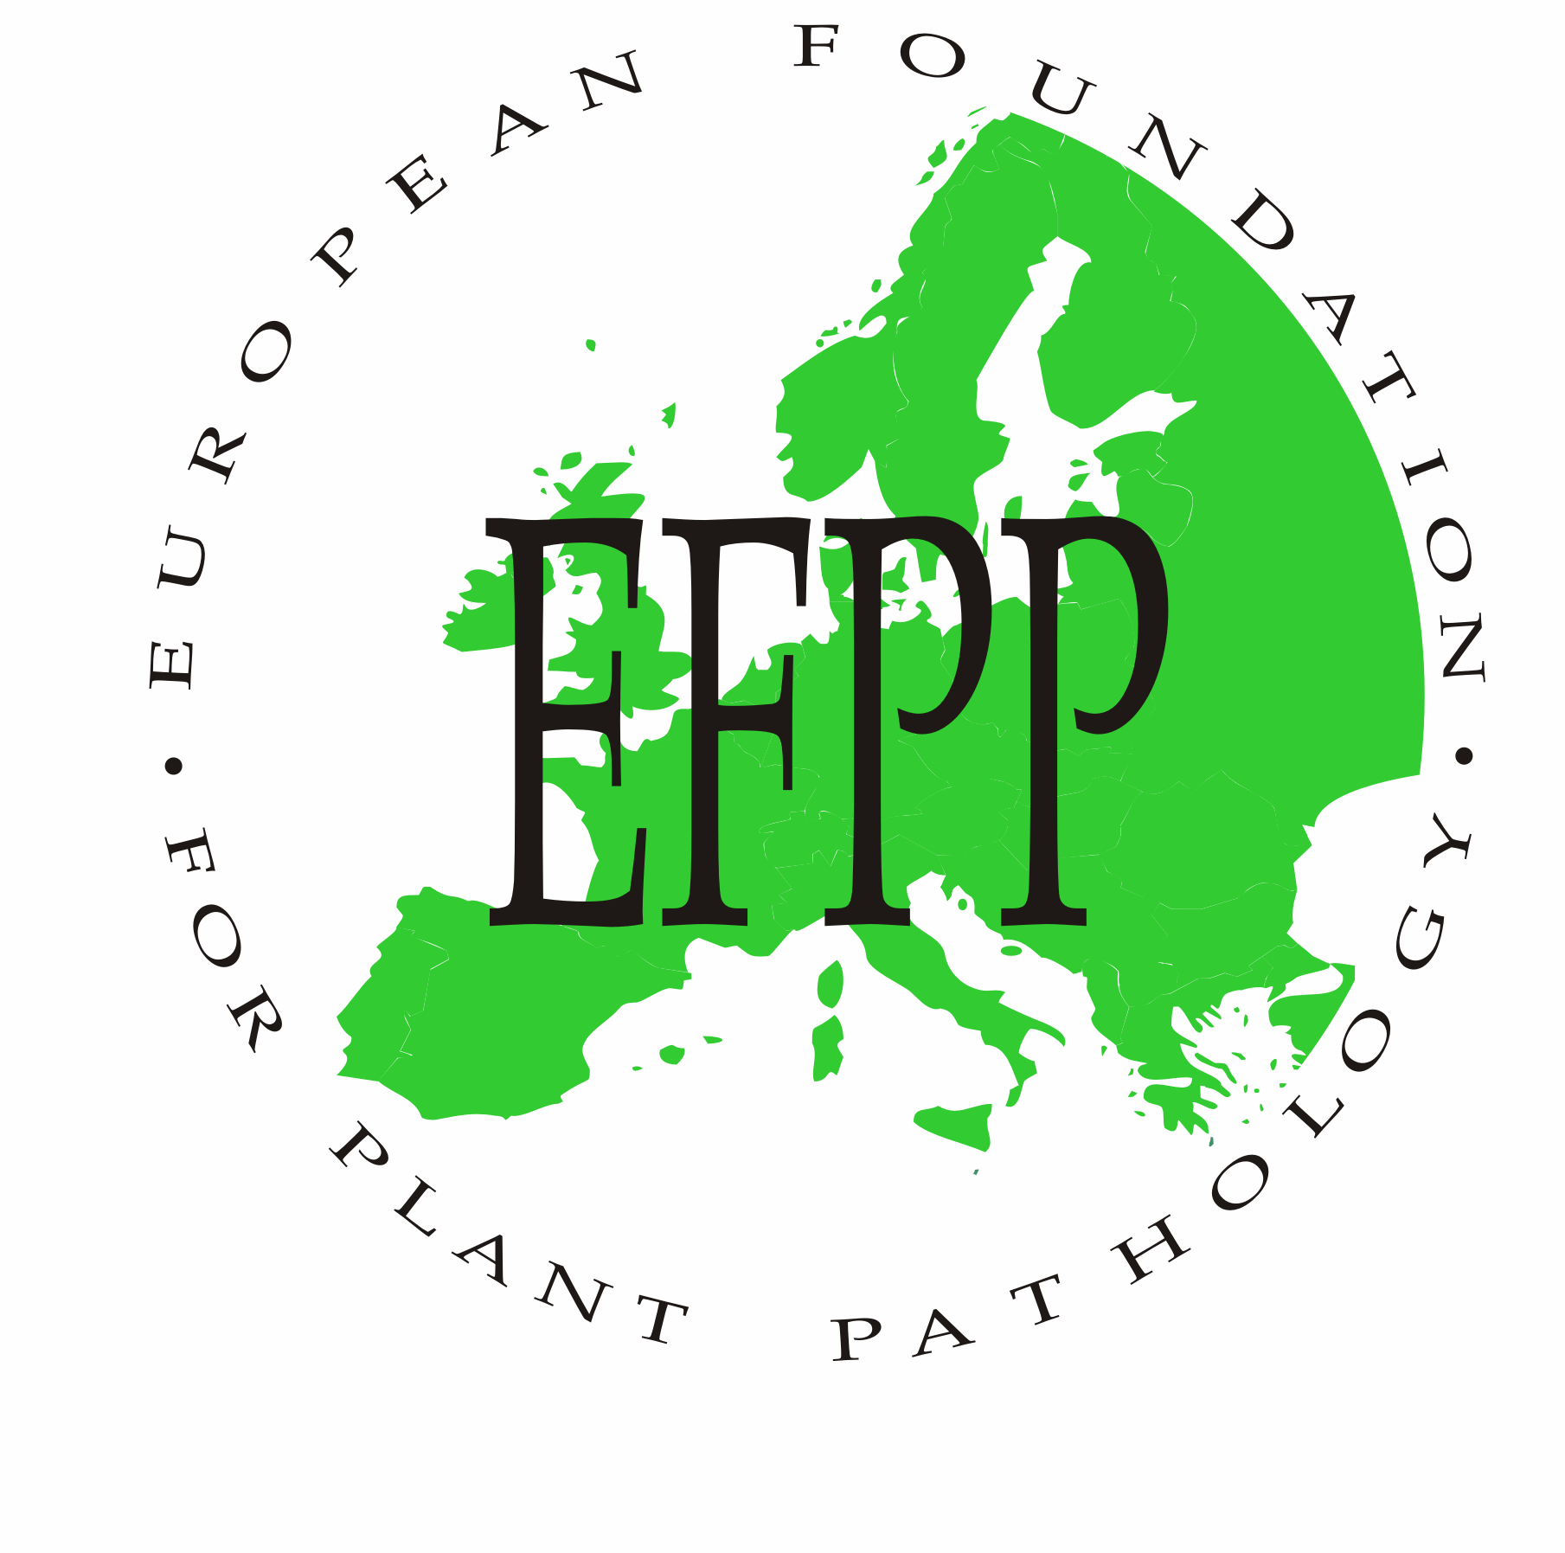
Draft

REPORT OF THE TENTH MEETING OF
THE BOARD OF THE EFPP
WITH DELEGATES OF MEMBER SOCIETIES

ÉVORA, Tuesday 16 November 2010, 18.30 - 20.00 hours

Attending:

M. I. Clara (Portugal- President)
P.M. Boonekamp (Netherlands – General Secretary)
A. Hermansen (Denmark – Treasurer)
J. Pólak (Czech Republic)
M. Manka (Poland)
D. Panka (Poland)
D-F. Jensen (Sweden)
J. Yuen (Sweden)

- Opening address by the President Prof. M.I. Clara

The meeting was opened and chaired by the EFPP-President, Prof. M-I. Clara, who welcomed delegates from the Member Societies. The President further appreciated assistance of the members of the Organising Committee for the excellent preparation and organisation of the 9th Conference in Évora. Then the participants of the meeting were asked to introduce themselves. The President announces that many delegates finally decided not to come due to difficulties with flying schedules, as the EFPP Conference coincided with the visit of President Obama to Portugal. But she is pleased that many are still participating, making the conference a success. The agenda was adopted.

- Minutes of the ninth Board Meeting in Copenhagen and matters arising

The President requested the approval of the minutes from the previous EFPP-Board Meeting. After a small adoption made by Dr. A Hermansen (he is from Norway not from Denmark), they were approved.

- Report of the General Secretary, Dr. P.M. Boonekamp

At the last EFPP-board meeting in Copenhagen it was decided that the EFPP-board should establish four actions: 1) to contribute to ISPP - a report has been sent to the Secretary of ISPP, 2) to find a successor for Prof Mike Cooke, the present Editor-in-Chief of EJPP – we are pleased that a perfect successor could be found in the person of Prof Mike Jeger, 3) to organize a meeting on climate Change and Plant Diseases – prior to the EFPP conference a successful Climate Change meeting has been organized in Évora, 4) to release a Newsletter EFPP to announce EFPP-actions and to request for additional ideas. Especially the Newsletter was meant to get input from members in order to revitalize EFPP. However the board did not receive any feed-back on the Newsletter and the President asks the participants for comments. Prof Manka mentioned that she did her best to activate the Polish society, but only received limited response. Prof. Polak mentioned that he did not receive information as outlined on p. 5 of the minutes. Therefore he did not receive much feed-back. The Évora meeting was also announced rather late and that is also the reason that the Czech delegation at this Évora meeting is rather small. He feels that communication needs to be improved. Dr. Funk Jensen mentioned that in the Nordic countries young scientists feel no longer connected to societies, and rather participate in small more targeted meetings. Prof Panka sees the same tendency in Poland. The General Secretary admits that communication was meager indeed, but everything what could be done from minutes has been done by the EFPP-board and communicated. And as we still did not receive any feed-back, this cannot be blamed on communication alone. It was decided to continue the discussion on this item at point 13 of the agenda, if time allows.

- Report of the Treasurer, Dr. A. Hermansen

The treasurer Dr A Hermansen presented the report on income and expenditure, for the years 2006 till 2009. They fairly present a slight decline of the positive financial position of the EFPP, due to the actions as decided during the last board meeting in Copenhagen as announced in the Newsletter at the end of 2008. Although 25 societies get requests; only 12 pay more or less regularly; some societies pay for more years. It was discussed how paying behavior can be improved. Some like the Czech society pay every year as they can only annually receive a subsidy from their government. The treasurer is not sending reminders yet, but from now on he will send invoices adding up all unpaid contributions from 2009 onwards. A problem is that many societies do not inform the EFPP-board on mutations and therefore the General Secretary of EFPP is not able to update the EFPP-website. Prof Polak asked whether it was not decided that 5 young scientists got rewards for posters etc? The treasurer replied that it concerns travel grants for 4 young scientists to participate in Évora and indeed applications have been granted.
The auditors Drs G. Rikheim and T. Wold have examined the financial statement and declared it correct.

- EJPP: Report of the Editor-in-chief Prof. M. Jeger

The Editor-in-Chief Prof M. Jeger stated that EJPP is still performing well: the number of accepted manuscripts as well as the impact factor stay on the same good level. The publisher Springer is satisfied on the quality and the smooth co-operation with the Editor-in-Chief and his team. As the editing group as a whole is performing well and all editing is done electronically, the speed of publication is much faster now. The Editor-in-Chief is doing much work on copy-editing to support the policy of EJPP that also scientists, not experienced in English writing, should get the opportunity to have their good scientific manuscript published in the proper English language.
He also announced that he is planning to combine some keynotes of the 9th EFPP Conference and of the Climate Change conference in a special issue of EJPP, to be released at the end of 2011.
The President acknowledged the dedication of Prof Jeger and expressed the wish that he will continue in this way.

- Report by Dr P. Boonekamp on the Conference on Climate Change & Plant Disease Management (Évora 10 – 12 November 2010)

Dr Boonekamp stated that it was quite a challenge to have about 35 scientists with various expertise from all over the world together, to discuss the unknown field of climate change and plant diseases. But the combination of some inspiring keynotes and informal debates in workshops turned out to be quite productive. The outcome was that a policy paper should be released (the paper ‘Plant Diseases Ignored in Climate Change Debate’ has been already published in Public Service Review: European Science and Technology 10, April 2011), some participants would write reviews for a special issue of EJPP, and that all contributions and discussions should be combined in a short report, available to all participants.
Especially the local organization of SPF (Prof Clara and her team) should be highly acknowledged for organizing a perfect venue in Évora and good local sponsoring, which really created the inspiring atmosphere needed to make the conference a great success. Also the Dutch KNPV should be specially acknowledged as they covered most of the financial costs, which was substantial as all participant had been invited and only had to pay their traveling costs. The organization was also very pleased that some oversea participants with high traveling costs were either reimbursed by the American APS or by EFPP.

- Election and appointment of officers of the EFPP:

- Appointment of the President: The Dutch KNPV; however the present president Dr G. Kema is about to resign so his successor will be the next EFPP president (N.B. the Dutch KNPV appointed in her spring meeting 2011 Dr P.M. Boonekamp as the new president)
- Appointment of the vice-president: Prof. M.I Clara
- Appointment of the treasurer: Dr. A. Hermansen
- Appointment of the general secretary: In case Dr. P. Boonekamp may have to resign as he is nominee for the Dutch presidency of KNPV, it was agreed by the participants that the general secretary should be Dutch as EFPP has its legal foundation in The Netherlands, and taken into account that Dr G. Kema is available, it was agreed that Dr Kema would be the successor of Dr Boonekamp
All nominated officers were unanimously elected, and they will form the Executive Committee of EFPP for the next term. It was also agreed that Dr Boonekamp would nominate a programme secretary for organising the next meeting in Wageningen and that the Executive Committee would decide on this nomination
Prof Clara expressed her special thanks to the resigning officers for all the work they have done for EFPP in the past period.

- Report of the eight EFPP-Conference 2006 in Copenhagen

Prof Clara acknowledge the resigning officers Prof. L. Munk and Prof. D. Jensen, Prof. S. Wale and Dr M. Dickinson. The joint EFPP and BSPP organized a very good conference in Copenhagen, and the proceeding of key notes in a special issue of EJPP are of high quality. Prof Jensen mentions that there is no formal report available and that there is no need for this, as all aspects have been covered well. There is one point left, some invoices of speakers still have to be dealt with to get them paid. This is however the (financial) concern of the Danish society and not EFPP.

- Status Report of the ninth EFPP-Conference 2010 in Évora (Prof. M.I. Clara)

Prof Clara mentions 100 registrations, some did not show up for unknown reasons. As sponsoring was not easy due to the economic crisis, prominent advertising of the conference was not possible and indeed some announcements were rather late. The conference had to be organized with limited budget, but with local support (winetrip etc.) we think that we were able to organize a good conference. Prof Clara acknowledge her coworkers for all the editing of the abstracts and all the practicalities for a pleasant stay in Évora. In addition she mentioned a price for the best poster from SPP, that the book of abstract will appear on the website, and that no financial support will be needed from EFPP.
The Board and delegates express their sincere thanks to Prof Clara and her staff for the perfect organization of the conference and for organizing a very pleasant stay for all participants in Évora.

- Progress Report of the tenth EFPP-Conference 2012 in The Netherlands (Dr. P. Boonekamp).

Dr Boonekamp announces that the KNPV is pleased to organize the 10th conference in Wageningen in 2012. He mentions that the new EU legislation on Crop Protection might be a good marking point to get plant disease on the EU agenda again. He suggested the topic: “Research - from fundamental to applied - to support the new EU-legislation on IPM implementation in the member states”. The idea is to make the general conference a bit shorter, but add some more targeted satellite workshops. The timing will be not later than end September/beginning October 2012 as an excursion to the large horticultural exhibition, ‘Floriade’ should be part of the program. After the summer of 2011 the first announcement will be released.
The EFPP-Board approved this proposal

- Progress Report of the eleventh EFPP-Conference 2014 in Poland

Prof. Manka mentioned that Cracow might be the venue for the 11th Conference in September 2014. The best option seems the Agricultural University, 3 km out of town which has all facilities to organize an international conference. She suggested the topic: ‘plant pathology in organic culture and biological control’.
The EFPP-Board approved this proposal

- Society bidding for the twelfth EFPP conference 2016 (bid opportunity for Member Societies)

There is no formal bid yet. The Nordic delegation agreed to investigate whether the Nordic and the Baltic countries could organize it together, and will inform the General Secretary. If it is not feasible, the EFPP-Board will call for countries that never organized the conference yet.

- Future of EFPP:

The actions as formulated in Copenhagen have been accomplished, but have not lead to a more active EFPP, and more participation of the member societies. As the number of delegates at this meeting was rather small, is was decided that the next presidency should pick up this issue and present some proposals at the next board meeting in Wageningen in 2012 . These actions included to establish a grant systems for best contributions of students to be decided by the students.
A positive issue is that delegates from the German society are joining the Évora meeting and consider to join the EFPP. The EFPP-Board approved this initiative.

- Any other business

No other business were addressed.

- Closing

The President Prof. Clara thanked all the delegates for their active participation and useful exchange of information. She wished much success to the EFPP in future.
The meeting was adjourned at 20.00 h.

